Assembled Items - Inventory

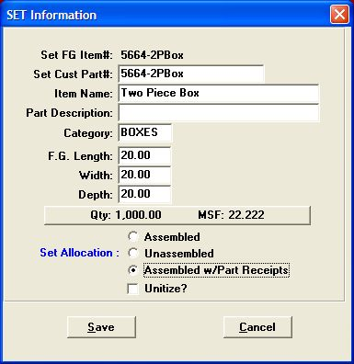
Set Allocation - The same fields are available in both cost estimating and finished goods.

Set Allocation Methods:
Assembled Sets (herein AS)
Unassembled Sets (herein US)
Assembled Sets with Parts Receipts, (herein ASP)

Finished Goods Receipts:
Data entry of sets into finished goods (set receipts) for AS will require component part receipts posted prior to the set receipt.
Receive part 1
Receive part 2
Receive part n…
Then –
Receive the assembled set. This relieves the parts and creates the set.

When US or ASP sets are added, the system will automatically add the components to the receipts screen, thus saving data entry time to add the components.
Therefore, ASP receipts will simply require adding the SET item receipt and the system will create the component receipts exactly as the US receipts. This logic mostly applies to Advantzware users that manually add receipts.

Touch Screen:
Users of Touch Screen may create component and/or set receipts via the plant floor. Touch screen users would “Post Inventory for Assembled Sets” when the assembled set receipt is posted, this will reduce the parts inventory and increase the sets on hand inventory. Whereas Unassembled Set receipts will increase the component parts and increase the set on hand inventory. Likewise, when the finished good receipt is posted for an ASP, set inventory will be increased and the components will be simultaneously increased and then decreased by the set quantity times each items qty/set. Please note, the receipts screen may be updated prior to posting to increase the receipt quantity of each component based on actual production data.

Bill of Lading Posting:
The bill of lading will reduce only ASP and AS quantity on hand whereas shipments for Unassembled Sets will reduce both the set and the component inventory.
Set Type | Recv to FG | Bill of Lading
Assembled Set | Post Parts, then the assembly | Reduces the set quantity on hand
Unassembled Set | Post Assembly only (the system will post the components). You can modify the receipts for the components if you overran any parts and want to maintain the inventory for them. | Reduces both the set and the component inventory
Assembled Set with Parts | Post Assembly only (the system will post the components). You can modify the receipts for the components if you overran any parts and want to maintain the inventory for them. | Reduces the set quantity on hand

